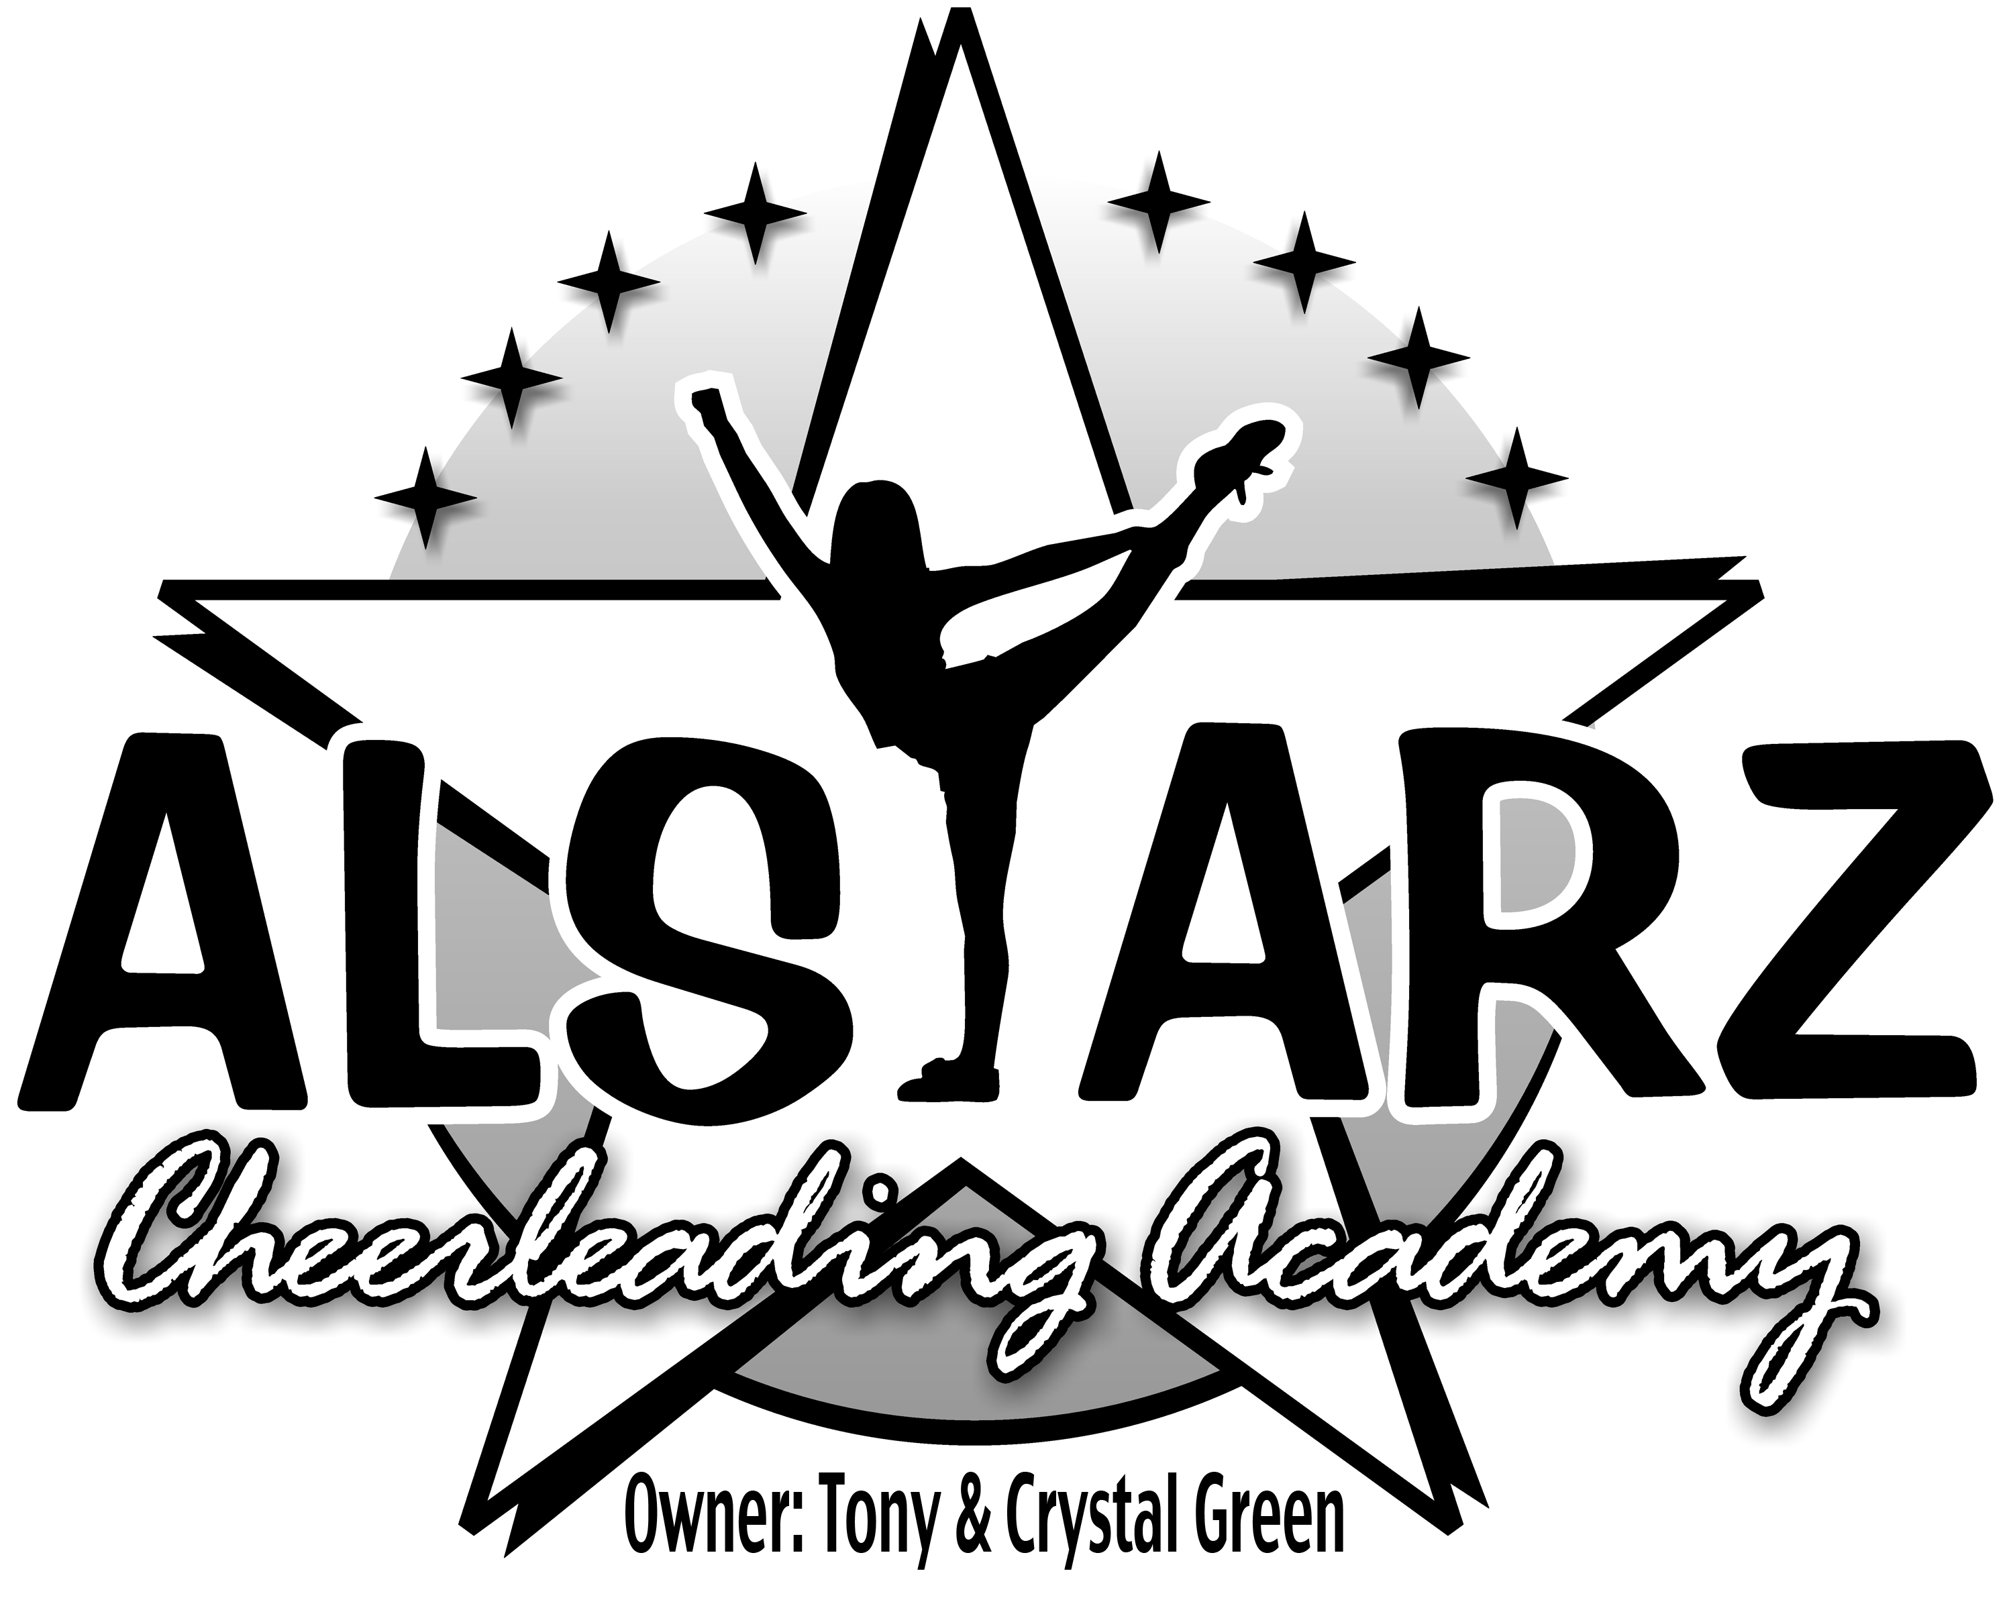

**SPIRIT DAY CHEER CAMP**

**Sat. Aug. 3, 2013 12-3pm**

**Show Off at 3pm**

**985-693-7109 www.alstarzacadmy.com**

**$25**

Athlete Name:___________________________________ Age: ________

Mailing Address: ______________________________________________

Parents Name: _________________________ Cell # ________________

E-mail Address: _______________________________________________

WAIVER

I,________________________, give my child, __________________________, permission to participate in ALSTARZ Cheerleading Academy’s Sprit Day Cheer Camp. I understand that cheerleading involves intense physical activity and the chance of injury does exist. My child is in good health & capable of participating in this type of activity. I release and agree to hold harmless the ALSTARZ Cheerleading Academy and it’s staff from any liability whatsoever. In case of emergency, I give ALSTARZ and its staff permission to call for medical attention.



**SPIRIT DAY CHEER CAMP**

**Sat. Aug. 3, 2013 12-3pm**

**Show Off at 3pm**

**985-693-7109** [**www.alstarzacadmy.com**](http://www.alstarzacadmy.com)

**$20 Pre Registration $25 at door**

Athlete Name:___________________________________ Age: ________

Mailing Address: ______________________________________________

Parents Name: _________________________ Cell # ________________

E-mail Address: _______________________________________________

WAIVER

I,________________________, give my child, __________________________, permission to participate in ALSTARZ Cheerleading Academy’s Sprit Day Cheer Camp. I understand that cheerleading involves intense physical activity and the chance of injury does exist. My child is in good health & capable of participating in this type of activity. I release and agree to hold harmless the ALSTARZ Cheerleading Academy and it’s staff from any liability whatsoever. In case of emergency, I give ALSTARZ and its staff permission to call for medical attention.